Restricting admin users on certain menus in the admin (v9.x):
- Go to {root}/admin/controls folder and duplicate the files: AdminMenu.ascx and AdminMenu.ascx
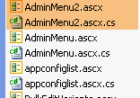
e.g.

- Open those files and change these lines accordingly:
(a) AdminMenu2.ascx:
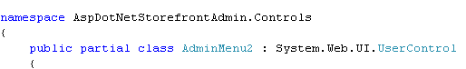
(b) AdminMenu2.ascx.cs:

- In your Adminmenu2.ascx.cs, comment out the appropriate lines below if you want to hide certain menus (e.g. ORDERS, PRODUCT, ETC) to admin users.
e.g.
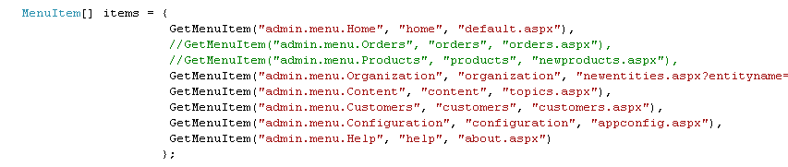

- If you just want to hide the sub-menus underneath the main menus, do this:
- Go to GetChildMenuItems() method, and for example, if you want to remove the recurring menu, then comment out these lines and so on.
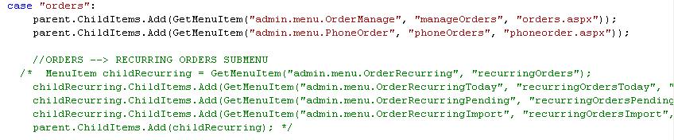

- After you’ve done all of those, go to Customers -> Edit/view customers and users, then select the admin user. From the “Notes” field on the customer profile frame, specify the Adminmenu2.ascx or whatever you named it and ‘update customer’.
e.g.
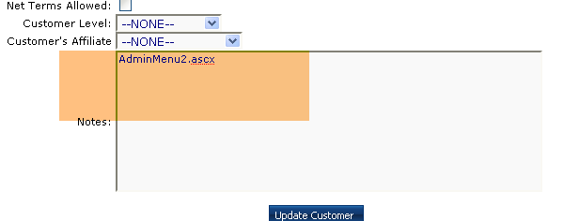
- Reset cache and that’s it!

